MANRRS NATIONAL STUDENT OFFICER CANDIDATE APPLICATION

Section I: Personal Information

LAST NAME: FIRST NAME:

GENDER: DATE OF BIRTH

PHONE #:
EMAIL ADDRESS: BLAZER SIZE
(number size): Section II: Education NAME OF SCHOOL: STREET ADDRESS: CITY:
STATE: ZIP CODE:
MAJOR: MINOR
(if applicable):
CLASSIFICATION/: YEAR IN SCHOOL: G.P.A.: EXPECTED DEGREE
COMPLETION DATE:

Section III: Office Desired

MARK DESIRED STUDENT OFFICER POSITION:

REGION (if applicable):

MANRRS CHAPTER/ INSTITUTION:

MEMBER SINCE:

YEAR OF SERVICE AS NATIONAL STUDENT
OFFICER (student presidents only)

Section IV: Applicant Requirements

All applicants are required to do the following:

- Record a short 3 minute video telling why you desire to serve as a National Officer.
- Complete a phone interview where you will be contacted upon full completion and submission of your application which is to include 3 recommendations: MANRRS advisor, college professor and employer (may use high school employer)
- Submit a current résumé
- Submit an unofficial transcript
- Must be available for the MANRRS event dates.

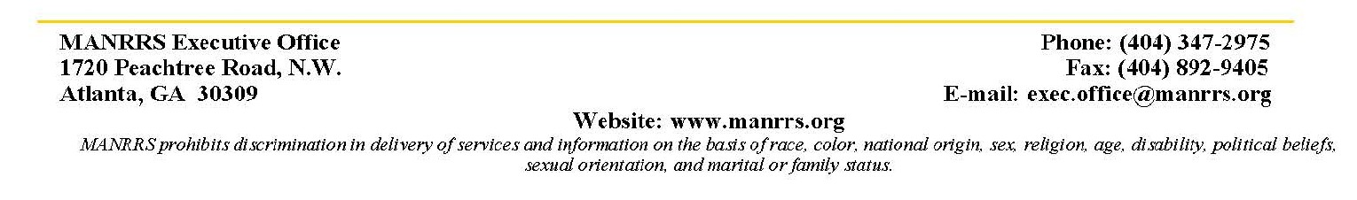

Section V: Essays

Answer ALL questions in 300 words or less, per question.

- What is the advantage of you being a member and officer of the MANRRS National Society?
- What skills and abilities will you bring to the position?
- What are the most impactful contributions you have made serving as a student leader in various organizations (i.e. MANRRS, SGA, etc.)?

Address the questions below as they may relate to you. Please answer only THOSE that are applicable. Regional Officer Applicants Only:
How have you been involved in your local chapter and region and how would you engage others to be involved in MANRRS?

Student President Applicants Only:
What goals would you set for your year of service as a Student President and how would you implement those goals?

Student Parliamentarians Only:
What innovative techniques would you use to help increase understanding of rules and procedures?

Section VI: Letter of Recommendation

The letter of recommendation is to be completed by your Chapter Advisor or Co-Advisor, an Academic Professor and an employer. The Advisor letter should verify your GPA, length of membership, and provide an explanation of why they are recommending the candidate for a position as MANRRS National Officer,

Recommendations should be submitted to: Mr. Karl Binns Jr., 2018-19 National President-Elect (karl.binns@manrrs.org) by the application deadline of March 4, 2019 at 11:59 pm EST.

Chair:
Mr. Karl Binns: National President-Elect
Email: Karl.Binns@manrrs.org
Phone: (443) 366-6085

Student President Candidates and Officers seeking Re-election ONLY: It is your responsibility to ask your current National President-Elect for a letter of recommendation. You should send a request to the National President-Elect (karl.binns@manrrs.org) for undergraduate and for graduate applicants. This letter of recommendation is due by March 4th, 2019 at 11:59 pm EST.

*Note: Candidates will not be able to view the letters*

Completed National MANRRS Student Officer Candidate Application in its entirety, including required signatures (see below).
- Submit current résumé
- Unofficial Transcript
- Proof of enrollment (graduate student applicants)
- Completed answered essay questions
- Submit3 letter(s) of recommendation include: MANRRS advisor, college professor and employer (may use high school employer)
- Complete electronic application with video and supporting documents on National
- Submit 3 minute video explaining why you desire to serve as a National Officer

Section VII: Application Checklist & Signatures

For Chapter Advisors or Co-Advisors (Independent Student Members please obtain a signature from your academic Advisor):

I acknowledge that has met the GPA requirement to be a national student officer and has been a member of our MANRRS chapter for at least one year.

Advisor's Signature/Electronic Signature

DATE:

Applicant's Signature/Electronic Signature

DATE:

